December 28th, 2008
Hi
Not much to write about. In the corresponding letter last year, I mentioned borrowing three books from the library to read, as I did not have any work to do. Quite different this year with the Indonesian primary science project to occupy me.
Last Monday, there was an appalling incident at a local hospital. A man had a heart attack on the roadside opposite to a Caritas hospital. His son rushed into the hospital to request help but this was refused and he was told to dial 999 for an ambulance (the hospital would not even do this for him!). The son did so but because of traffic delays and a one-way street, it was 26 minutes before the ambulance arrived at the hospital (where of course, the victim had been earlier) but it was too late; he died shortly before arrival. The hospital senior administrator later went on TV to explain that anything that happened outside the hospital was not their responsibility! What a furore this created in the community, and rightly so. It is very hard to comprehend that this could have happened.
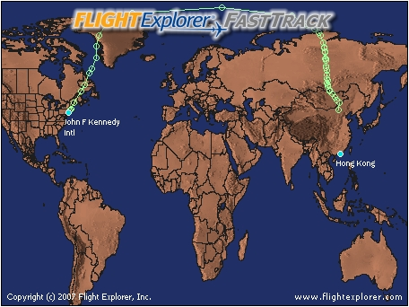
I went to the airport on Wednesday evening to see Nadine during her wait for the connecting flight to Sydney. Because the ‘plane arrived about 30 minutes early and the flight to Sydney was 15 minutes late, we managed to squeeze in about 1 hour 40 minutes. (The flight the day before was also early but others have been up to five hours late because of the bad weather in the US.) Good to see her. During the day, I had been using an Internet flight tracker to follow the progress of her flight (see below). I was surprised to see that the ‘plane actually flew eastwards from NY, over Boston, Greenland, north of Europe (at 80⁰ N, close to the North Pole) and then straight down across Russia and China to HK. I was expecting the flight to proceed westwards from NY. But in a way this makes sense. As NY and HK are almost exactly on opposite sides of the world, by flying eastwards it can catch the jet streams, which also flow in that direction and so save time. I guess that the return flight will fly westwards from HK across the Pacific to again catch the jet streams. It is fortunate that Nadine has a NZ passport, as everybody (except NZ passport holders) needs a visa to enter Australia, which Nadine did not have.
Interesting that the next evening, on ’60 minutes’, there was an item on security at US airports and the hassles people have to go through.
I went for a slightly longer run yesterday – from Tai Po, up to lead mine pass, then Tai Mo Shan and down to Route Twisk and on to Shek Kong. At 2 hours 38 minutes, it was one minute slower than last year, but five minutes off my best. I am probably getting too old to be expecting to set any fastest times for my runs! I have thought that about not wearing a watch and so not being able to compare times. I was a bit tired in the afternoon though.
That’s about it for now. Even with little to write about, I can still often find enough to fill a page. Last letter for 2008.

Cheers

